PRESIDENT’S OFFICE
REGIONAL ADMINISTRATION AND LOCAL GOVERNMENT
ARUSHA REGION
FORM TWO MOCK EXAMINATION
Code: 032 CHEMISRTY
TIME: 2:30 Hours MAY 2024
INSTRUCTIONS:
- This paper consists of sections A,B and C with a total of ten(10) questions
- Answer ALL questions
- Write your name and school name in the spaces provided
Atomic masses H=1, C= 12, O= 16, Na= 23, Ca= 40

- For each of the following items (i) – (x) choose the correct answer from the given alternatives and write its letter besides the item number in the box provided below;
- The Brownian movement is taken to be an evidence of the:-

- Newton’s theory
- Theory of colloidal suspension.
- Kinetic theory of behaviour of substance.
- Theory of association of water molecules.
- Theory of ionization.

- When oxides of most non-metal are in water
- Dilute neutral solutions are formed.
- Alkaline solutions are formed.
- Acidic solutions are formed.
- Concentrated hydroxides are forms.
- Amphoteric hydroxides are formed.

- The bunsen burner flame produces much soot which is the correct conclusion:-

- The air hole is closed.
- The air hole is open.
- The burner gas jet is big
- The gas supply is poor.
- The burner gas jet is small.

- Oxygen gas can be produced in a larger scale by
- Condensation of air of liquefied air.

- Condensation of air.
- Liquefaction of steam.
- Fractional distillation of liquefied air.
- Evaporation of liquefied air.

- Water is referred to as the universal solvent what does this mean?
- Water dissolves both organic and in organic solutes.
- Water exists in three states of matter than any other liquid.
- Water is used more domestically than any other liquid.
- Water dissolves more substances than any other liquids.
- Water is neither acids nor basic compared other liquids.

- Which of the following cannot be used to prepare hydrogen gas?
- Reaction of water with carbon at room temperature.
- Reaction of dilute acids with zinc.
- Electrolysis of water.
- Reaction of water with certain metals.

- The main aim of destructive distillation of coal is:-
- Removal of oxygen in the atmosphere
- Removal of volatile matter.
- Addition of volatile matter.
- Addition of oxygen in the furnace.

- A good fuel is determined by............
- Energy value.
- High content of non –combustible material.
- Scarcity of the fuel.
- High production of carbon dioxide.

- Which of the following statements about water is not true?
- Water is used in industry as a coolant.
- Water is used as a raw material to produce hydrogen.
- Water is used as a solvent.
- Water is used as a raw material to produce carbon.

- Identify the process used to remove contaminant from water.

- Water purification.
- Sedimentation.
- Electrolysis.
- Contamination.

i | ii | iii | iv | v | vi | vii | viii | ix | x

- Match the items in list A with the responses in list B by writing the letter of the correct responses beside the item number in the box provided below.
LIST A | LIST B
- Class C fires.  - Combustible.  - Class F fires  - Fire triangles  - Class B fires | - Use wet chemical extinguisher  - Fire resulted from fat and oil.  - Materials that produce heat on burning.  - Fire cause by flammable gases.  - Used to refer items needed to start fire.  - Fire caused by flammable liquid.  - Fire caused by flammable solids.  - Fire caused by electrical appliances

LIST A | i | ii | iii | iv | v
LIST B

SECTION B (70 Marks)
Answer all questions.

- (i)Study the diagram below and answer the questions that follow;

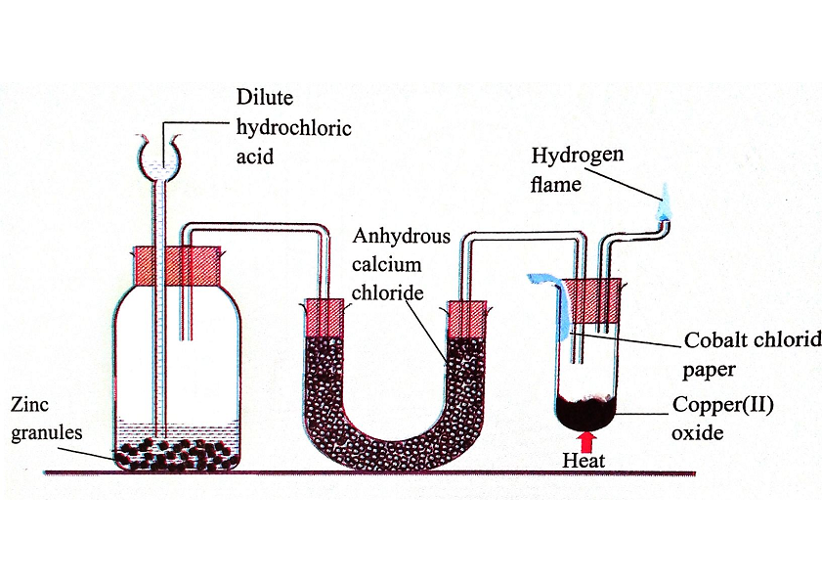
  - What is the colour of the solid product? ......................................................................................
  - Name the products formed……………………………………………………………………..
  - What is the role of the following chemicals?
- Hydrochloric acid and Zinc granules……………………………………………………….
- Anhydrous calcium chloride…………………………………………………………………
- Cobalt chloride paper………………………………………………………………………...
(ii) When green grass was crushed with toluene. (Methyl benzene) a green solution was formed – what method of separation can be used to show that this solution containing at four different substances? ...........................................................................................................................................
- (a) Explain the stages of urban water treatment…………………………………………………………………………………………………………………………………………………………………………………………………………………………………………………………………………………………………………………………………………………………………………………………………………………………………
(b) Explain why air is said to be a mixture of gases………………………………………………………………………………………………………………………………………………………………………………………………………………………………………………………………………………………………………………………………….
(c) A student wanted to prepare oxygen, by heating an oxide of mercury. His teacher did not recommend the method, what do you think could be the reason? ................................................................................................................................................................................................................................................................................................................................
- (a) Alex wanted to test for substances he could use to test for the presence of water in a certain compound. She put some hydrated copper (11) sulphate on a watch glass and added a few drops of distilled water to it (there was no charge in colour)
- Why there was no change in the colour of the copper (II) sulphate?
………………………………………………………………………………………………
- Name two substances he could have used in place of copper (II) sulphates to observe the required colour change. ………………………………………………………………………..

(b) Write the chemical symbol of the following elements
- Sodium…………………
- Magnesium……………….
- Chlorine…………………..

- (i) Give reasons to support each of the following statements;
  - A laboratory should be equipped with working fire extinguishers
………………………………………………………………………………………………….
  - A laboratory should have large windows.
…………………………………………………………………………………………………….
  - Chemicals which are not correctly labelled should not be used in the laboratory.
……………………………………………………………………………………………………
(ii)Explain the importances of changing one states of matter to another. Three (3) points
- ………………………………………………………………………………………………..
- ………………………………………………………………………………………………..
- …………………………………………………………………………………………………
(iii) With the aid of diagrams, illustrate how a portable fire extinguisher should be used.

- (a) Explain why petroleum and coal are non-renewable sources of energy
………………………………………………………………………………………………………

(b)Oxygen gas can be prepared by thermal decomposition of potassium chloride using manganese dioxide as a catalyst.
- Draw well diagram to show how oxygen is prepared using this method.

- Write word and chemical equation for this reaction.
………………………………………………………………………………………………….
(c)Explain the importance of chemical symbols.
…………………………………………………………………………………………………………….
- (a) What are the warning symbol you would expect to see on
- A can of petrol………………………………………………………………………………….
- A bottle of concentrated sulphuric acid…………………………………………………………
(b) Nekumo is a form one student at open school accidentally he mixed sulphur and iron fillings.
- Suggest an appropriate method of separation you would advise him to use to separate the mixture………………………………………………………………………………………….
- Give a reason for the choice of your answer……………………………………………………..
(c) (i) Mention the necessary correlation for rusting to occur.
………………………………………………………………………………………………………………………………………………………………………………………………………………………..
- Mention two (2) effects of rusting
……………………………………………………………………………………………………………………………………………………………………………………………………….
- (a) How to provide first aid to a person affected with electric shock.
……………………………………………………………………………………………………………………………………………………………………………………………………………………………………………………………………………………………………………………………………………………………………………………………………………………………………………………………………………………………………………………………………………………
(b) Differentiate mixtures and compounds. Four (4) points.
- ……………………………………………………………………………………………….
- ………………………………………………………………………………………………
- ………………………………………………………………………………………………
- ………………………………………………………………………………………………..

SECTION C
- (a) Draw a well labeled diagram of a small laboratory heat source consisting of vertical metal tube connected to a gas source.
(b) Describe how you will light a device drawn above
- ........................................................................................................................................................................................................................................................................................................
- ........................................................................................................................................................................................................................................................................................................
- ........................................................................................................................................................................................................................................................................................................
- ........................................................................................................................................................................................................................................................................................................
(c) Give four differences between a flame produce when the air holes of a bunsen burner are open and the one produced when the air holes are closed.
Flame when air holes open | Flame when air holes closed

